Lab 4: UI Design [Toolbar and Creating Multiple Forms]
Course: BESE 15 B | Instructor: Lab Engr. Nausheen

Objectives
In today’s lab, you will learn about:
- Toolbars
- Creating multiple Forms
- Modal and Non Modal Forms
- Passing Values between Forms
TASK 1
Note: This task comprises practice exercises and you do NOT need to submit this task.
- Adding a Toolbar
- Start a new project, expand the Toolbox and locate the ToolStrip control and add it to your form by double clicking it.
- On the top of the Form you will see some thing like this :
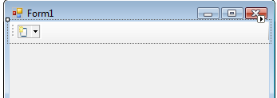
- While on the bottom you will have the ToolStrip control:
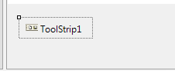
- Clicking on the top strip, add few buttons to the toolbar:
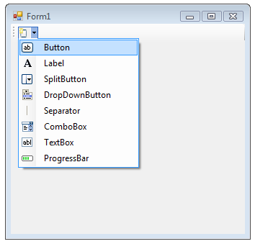
- Your form should look like:
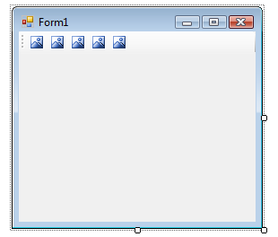
- Select the ToolStrip control from the bottom, inspect the properties dialog box and find the properties ‘Items’:
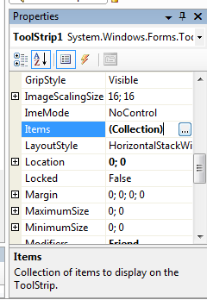
- Expand the ‘Items’ Property and you will have a dialog box like this:
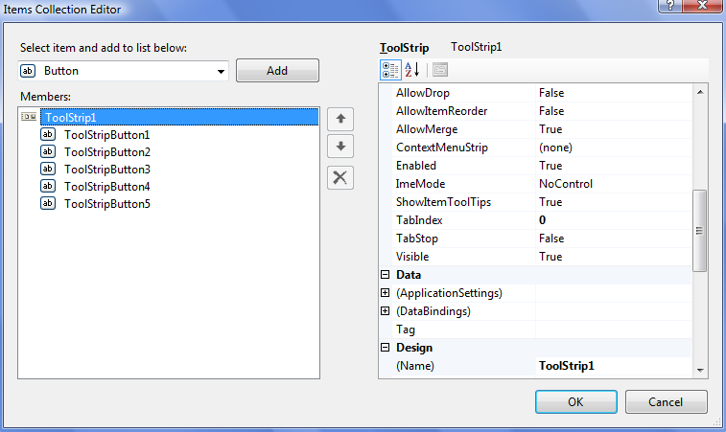
- The buttons added to the Toolbar are visible in the Dialog box. We want our toolbar to contain the following buttons:
  - File Open
  - New File
  - Save
  - Copy
  - Print
- Select each of these buttons one by one and change the following properties:
  - Name: Give a meaningful name to each button.
  - ToolTip Text: A small text message that would appear on the button once you move mouse over it (a help message).
  - Image: Assign an image (from the images provided) to each button.
- Performing these steps, your Form will look something like:
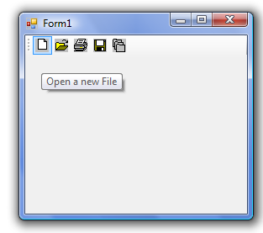
- If you move your mouse on the buttons (in the Run mode) you will see the message that you added to the ToolTip Text property.
- Add a simple message box to each of these buttons and verify the working of your program.
- Creating Multiple Forms
- To add another form to your existing project:
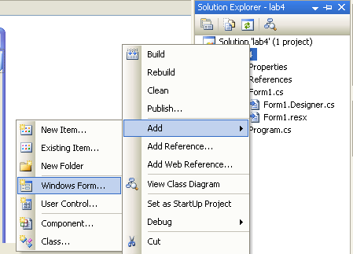
OR:
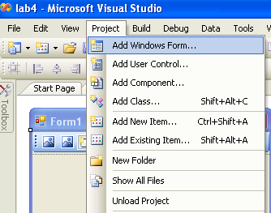
- Create a button on Form1, add following code inside the Click Event handle:
private void button1_Click(object sender, EventArgs e)
{
Form2 secondForm = new Form2();
secondForm.Show();
}

We have created a new object of the class Form2 and called its ‘Show’ method. When user will click button on Form1, Form2 will be displayed.
- Run your program and test it. When you click your button, you should see the second form appear.
- However, there's a problem with this code. Click the button again and another copy of Form2 appears. Keep clicking the button and your screen will be filled with the second form!
- To prevent this from happening, you can move the code that creates the form object like shown below:
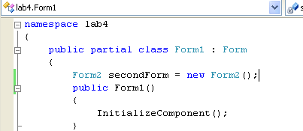
- The only code left in the button is the line that shows the form. A new form object will now not be created every time the button is clicked.
- Modal and Non Modal Forms
- A modal form is one that has to be dealt with before a user can continue. An example is the Format->Paragraph dialogue box in Microsoft Word. If you try to click away from the dialogue box, you'll here a beep to indicate an error. Until you click either the Cancel or OK buttons, the program won't let you click anywhere else.
- The second form you've just created is called a Modeless form. These are forms than can be sent to the taskbar. You can then return to the main form or program and do things with it.
- A Modal form is sometimes called a dialogue box. And we'll see how to create one of these now.
- To display a form as a Modal dialogue box, you use the ShowDialog method. If you use the Show method, the form is displayed as a Modeless form.
- Run your program and Click the button to display the second Form. Move it out the way and try to click a button on Form1. You won't be able to. The second form has to be dealt with before you can access Form1.
- Now add two buttons to the second Form to have something like this :
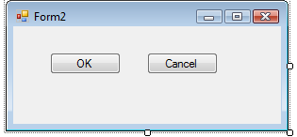
- Add the following functionality to the OK button
this.DialogResult = DialogResult.OK;
- Similarly, the Cancel button add the following code:
this.DialogResult = DialogResult.Cancel;
- Now access your Form1 code, and locate the lines that display the second form. Replace with following code:
DialogResult result;
result = secondForm.ShowDialog();
if(result==DialogResult.OK)
{
MessageBox.Show("OK button clicked in the second form");
}
else
{
MessageBox.Show("Cancel button clicked in the second form");
}

- Run and test your code.
Getting Values from other forms
- The form with OK and Cancel buttons is not doing much work so let's turn the form into a Change Case dialogue box.
- Change the design of your second form to look like the following :
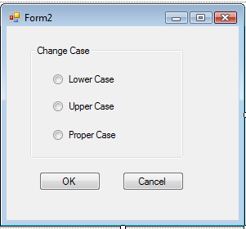
- When you've designed your form, click back on Form1 and add a Textbox to it. When a button on Form1 is clicked, the dialogue box above will be displayed. You can then select an option button to change the case to Upper, Lower or Proper case. This will happen when the OK button is clicked. Whatever text is in Texbox1 on Form1 will be changed accordingly.
- Now, create a textbox on Form1, and add following code in Form1.cs:
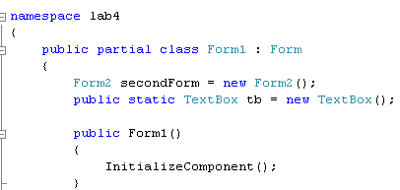
- In the code given above, a variable tb is defined which can store a Textbox object. Notice that the variable is declared Public so that we can see this variable in Form2.
- Double click anywhere on Form1. This will open the Form1_Load function that is called immediately once you execute the program and the Form is loaded. Add the following line:
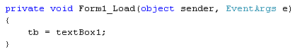
- Double click the OK button on Form2 to access the code. You should have the following:
this.DialogResult = DialogResult.OK;
- Modify the function as show below:
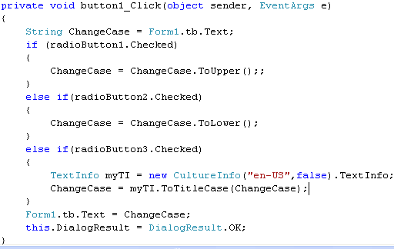
- Run your program, enter some text into Textbox1. Then click the button that brings up the Change Case Dialogue box. Select any option and click OK. The case of contents present inside Textbox1 on form1 should convert accordingly.
TASK 2
You have to design a flight search interface. An example interface (Reference: http://airblue.com/index.asp) could be:
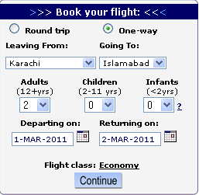
- Note: The interface presented is just an example; you are free to add your personal preferences of colors, fonts, layouts etc
- When user clicks Continue Button, display the summary of travel options selected by user on another dialogue box.

